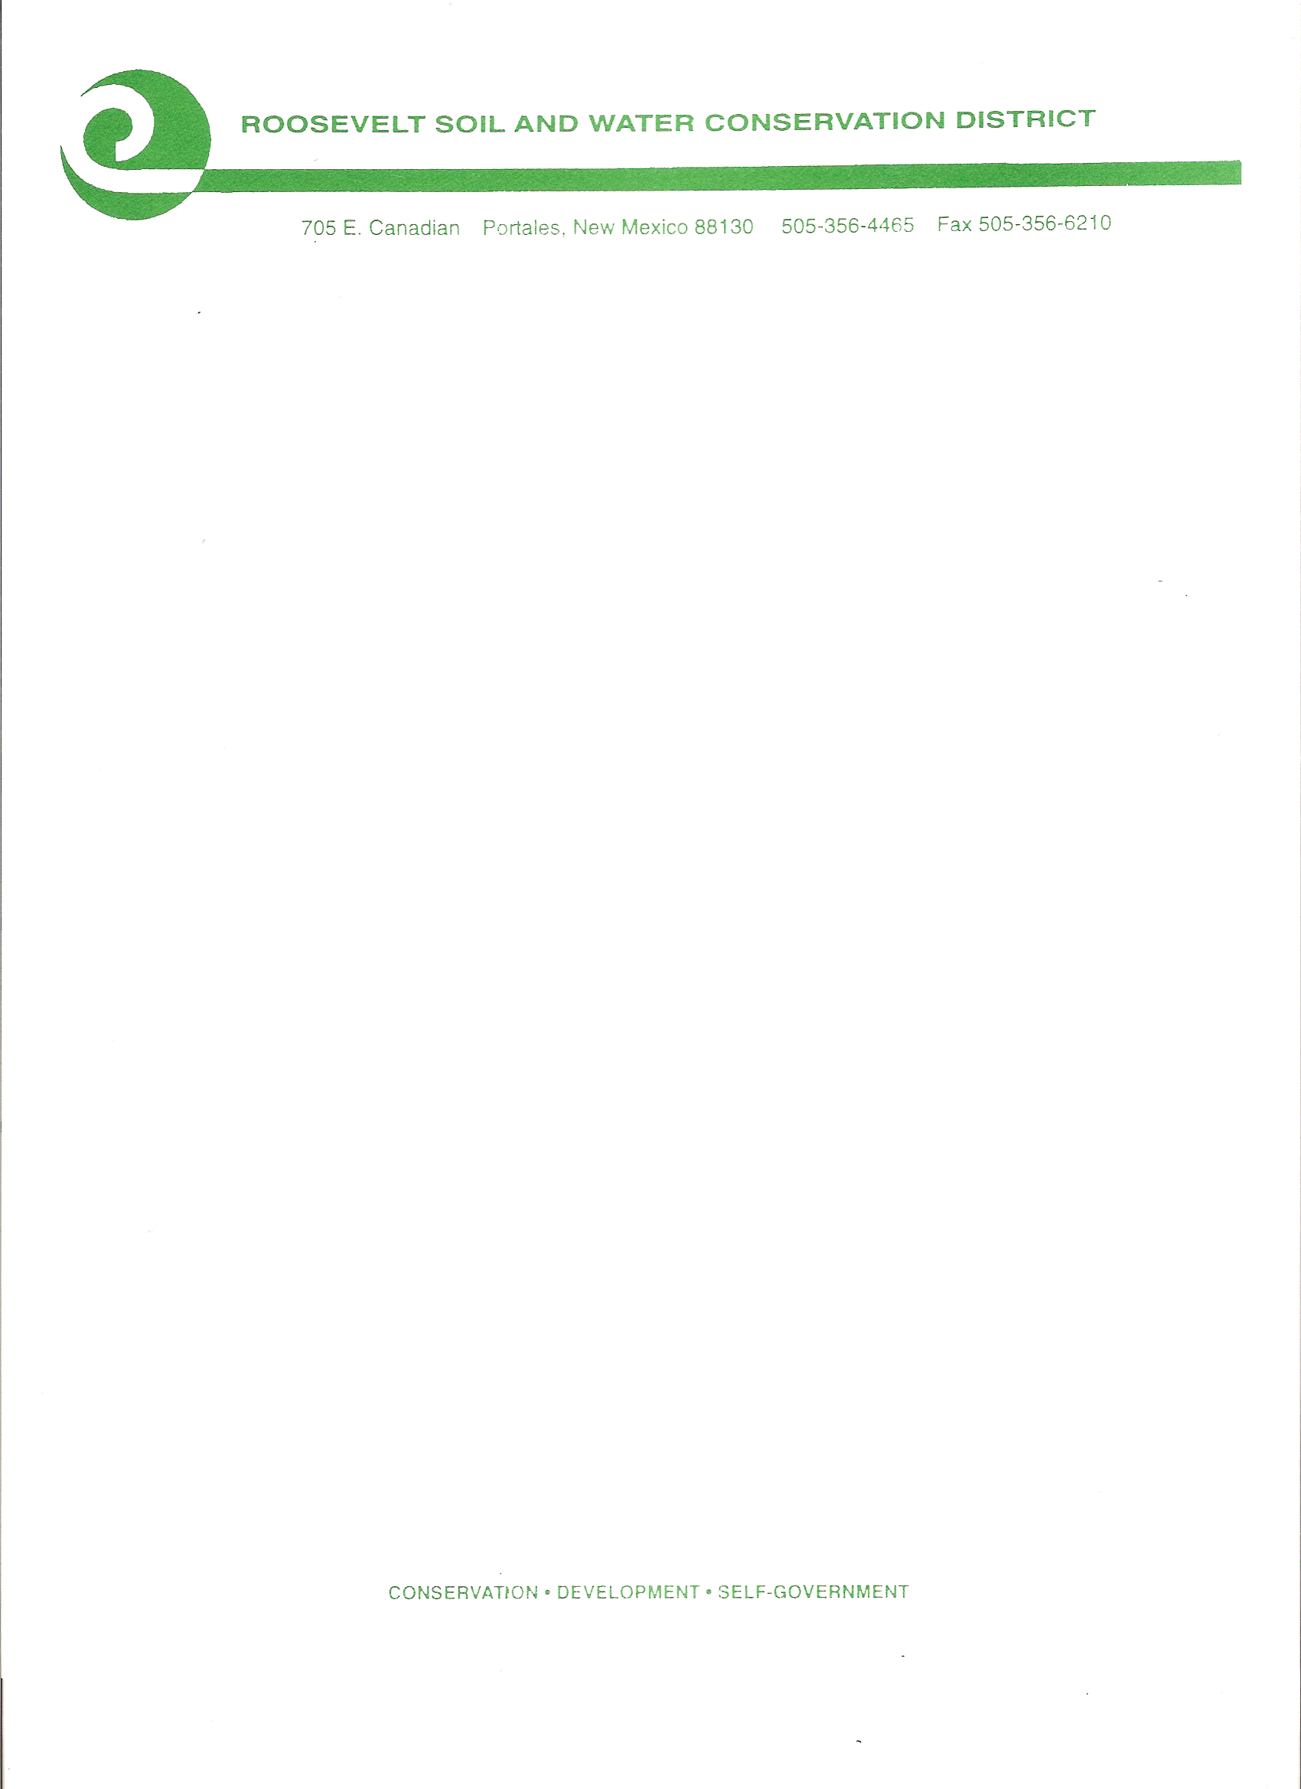

The Roosevelt Soil & Water

Conservation District

will conduct its

Monthly Board Meeting

on Thursday

November 17, 2022, at 7:00 a.m.

Zoom Access Available

For Zoom Info, Call 575-607-6383

Public Comment will be limited to 2 mins. per person. Time limit for public comment will be 30 minutes total.

**CONSERVATION…DEVELOPMENT…SELF-GOVERNMENT**

**050 NM Highway 467 Portales, New Mexico 88130 (575) 356- 6629**