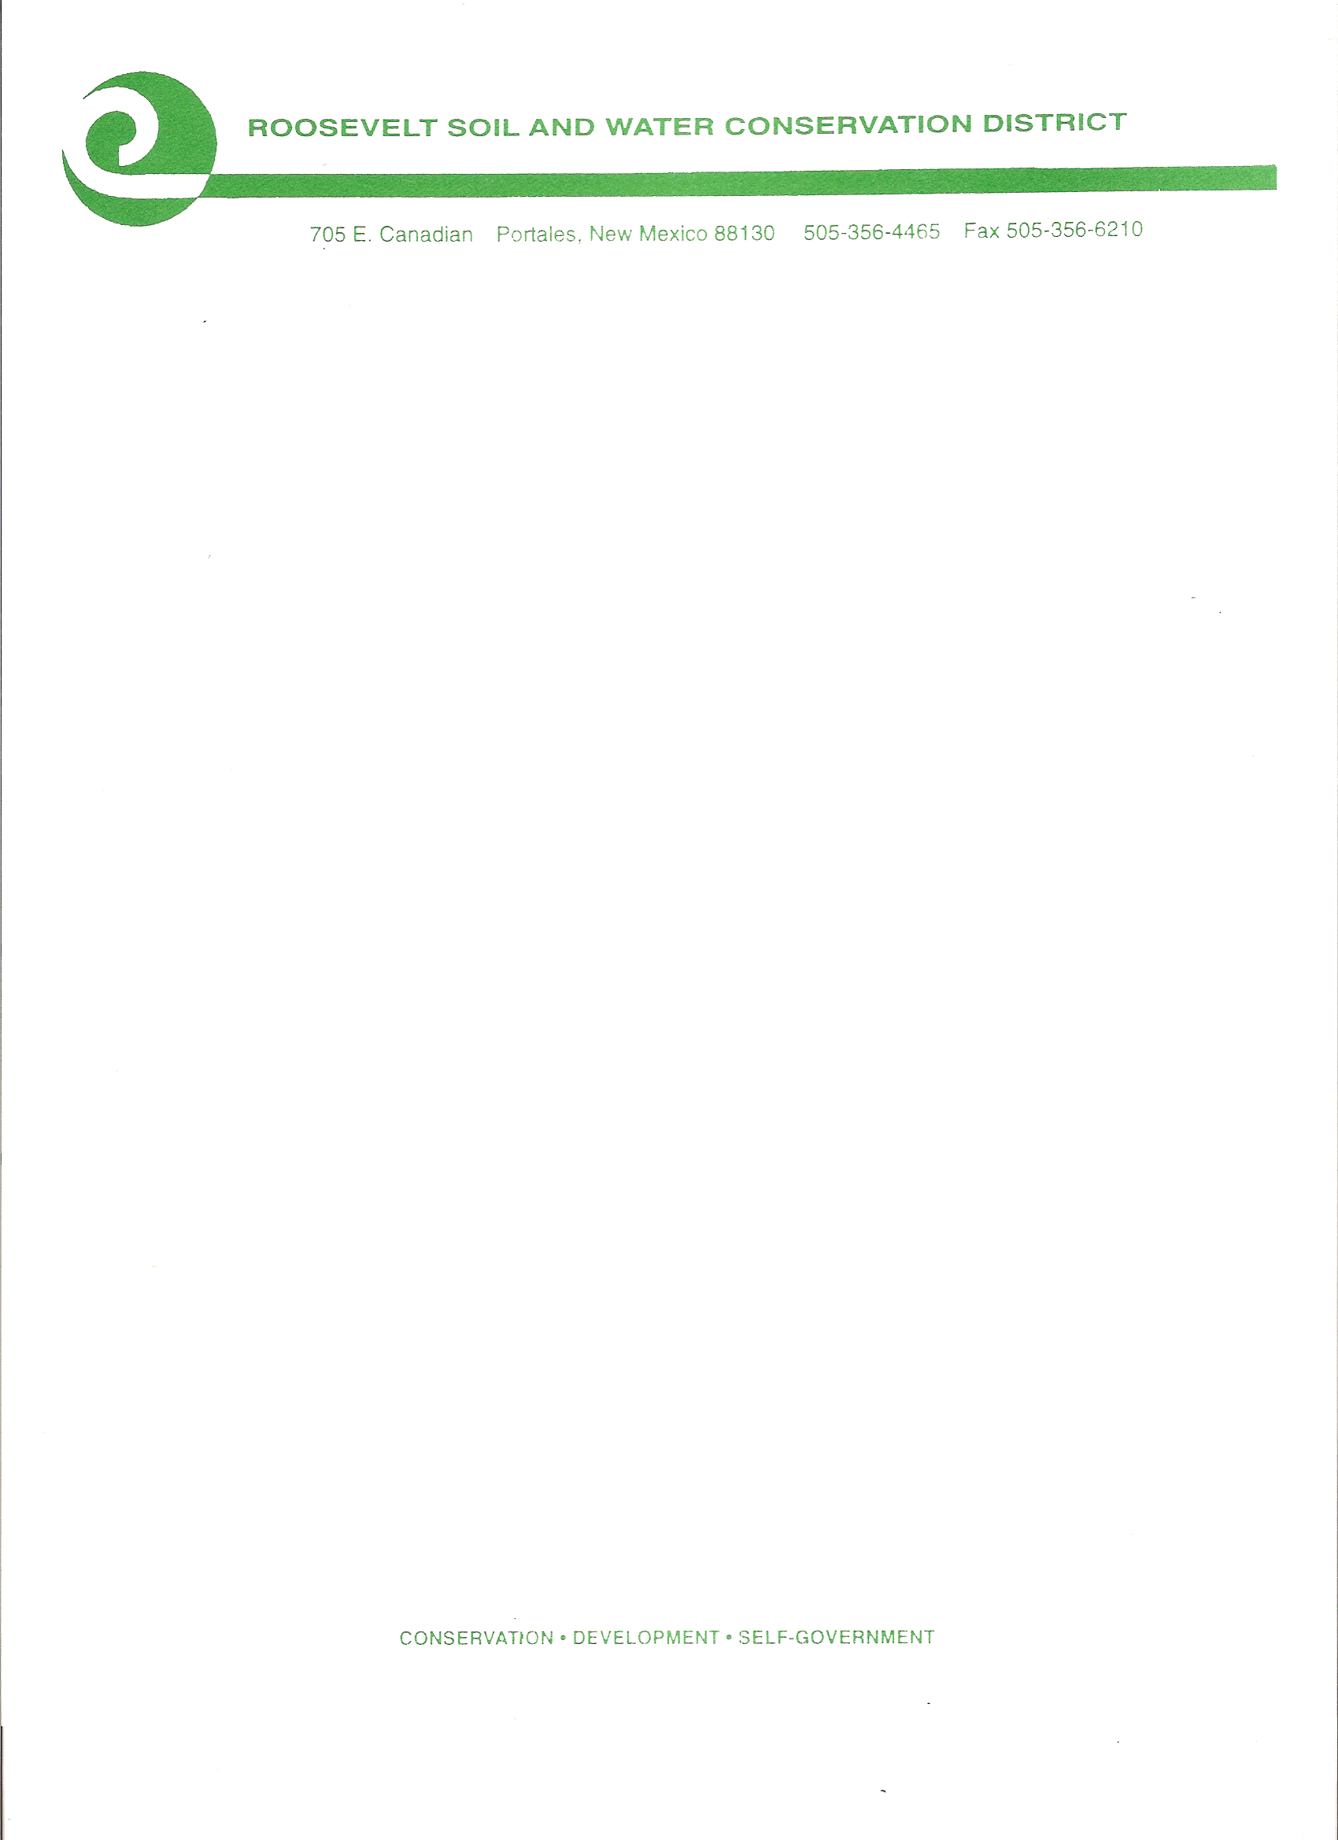

The Roosevelt Soil & Water

Conservation District

will conduct its

Monthly Board Meeting

on Thursday

April 14, 2022, at 7:00 a.m.

Via Zoom Meeting

Meeting ID: Meeting ID: 830 7066 1063

For password, please Call 575-607-6383

Public Comment will be limited to 2 mins. per person. Time limit for public comment will be 30 minutes total.

**CONSERVATION…DEVELOPMENT…SELF-GOVERNMENT**

**050 NM Highway 467 Portales, New Mexico 88130 (575) 356- 6629**