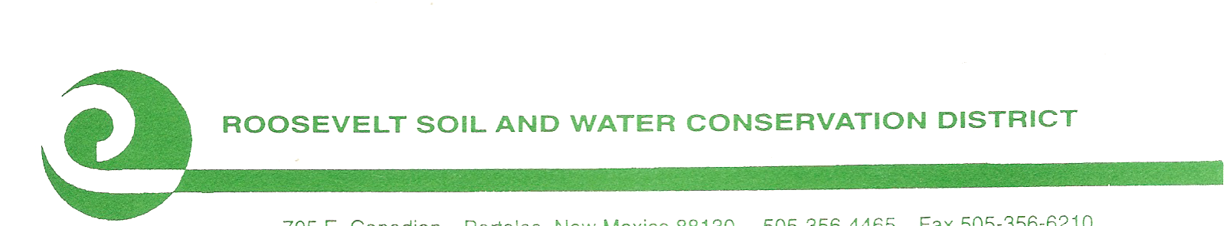

The Roosevelt Soil & Water
Conservation District
will conduct its
Monthly Board Meeting
on Thursday
December 4, 2025, at 7:00 a.m.
Meeting will be held at
050 NM Hwy 467 in Portales.

For Zoom Info, Call 575-607-6383

Public Comment will be limited to 2 mins. per person. Time limit for public comment will be 30 minutes total.

CONSERVATION…DEVELOPMENT…SELF-GOVERNMENT

050 NM Highway 467 Portales, New Mexico 88130 (575) 356- 6629

