# Autumn leaves in a tree

# CONSERVATION NEWS

# Roosevelt Soil & Water Conservation District

# USDA/NRCS & FSA Portales

# NOVEMBER 2020

Roosevelt SWCD

050 NM Hwy 467

Portales, NM 88130

575-670-6383

[rooseveltswcd@gmail.com](mailto:rooseveltswcd@gmail.com)

<https://rooseveltswcd.wixsite.com/mysite/contact>

Board Members:

Chairman: Mike Cone

Vice Chair: Mitzi Miller

Secretary: George Hay

Treasurer: Rick Ledbetter

Supervisor: Don Sanders

Supervisor: Quentin Carnes

Supervisor: Sharon Davis

Admin. Asst.: Dawn Privett

NRCS District Conservationist: D’Llaynn Bruce

FSA Executive Director: Harold Terry

Board Meetings held every second Thursday in our office or via Zoom.

NEW Cost-Share Program

The Roosevelt SWCD is currently taking applications for a cost-share program for farmers and ranchers in our District. Any person addressing a natural resource problem who owns land within the Roosevelt Soil & Water Conservation District boundaries is eligible. Applications will be approved on a first-come-first-serve basis. (See enclosed application.)

# Shade Ball Water Conservation Project Cost-Share Program

Cover your tanks before the cold weather hits! Shade balls help reduce ice formation considerably in your drinkers.

Due to a generous funding from a New Mexico Water Quality & Conservation Grant, we are currently providing a cost-share program to our landowners in the state of New Mexico.

To obtain an application and/or place an order, contact us at 575-356-6629 or email us at rooseveltswcd@gmail.com.

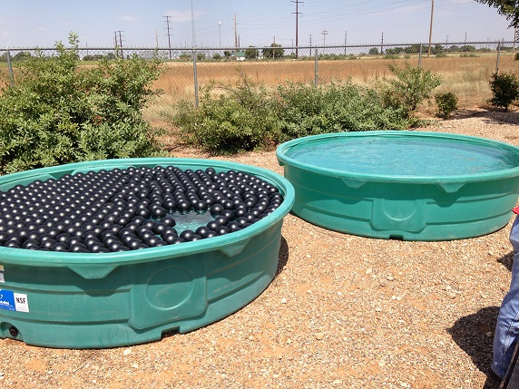

# 

Pre-Order your spring trees now. Call or email for a current price list. Drip supplies and weed barrier also available.

Roosevelt & Lea Soil & Water Conservation Districts conducted a cloud-seeding research project in Roosevelt and Lea Counties during the month of June of 2020. We are currently researching possible funding for ground-based and aerial cloud seeding throughout New Mexico for the upcoming year.

WEATHER MOD PROJECT

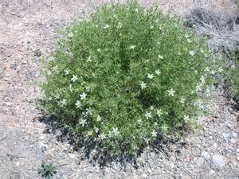

**Chemical available to spray African Rue. Call 575-670-6383.**

Roosevelt Soil and Water Conservation District, USDA-NRCS Portales, and Farm Service Agency Portales

[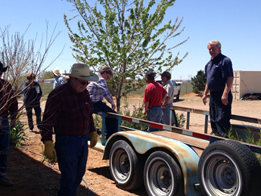](http://www.bing.com/images/search?view=detailV2&ccid=dgFkik1X&id=BE5C94E842509BEE7C1C2D8859FF1D0C452ABC47&thid=OIP.dgFkik1XWDfUpOZ1ctxOEwEsDh&q=weed+barrier&simid=608041446659655520&selectedIndex=50) [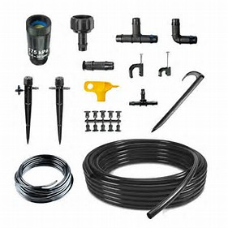](http://www.bing.com/images/search?view=detailV2&ccid=Z62LQI2Q&id=50D2BC4B302BACC6A86CAB5713626C430283E9BC&thid=OIP.Z62LQI2QWsFhom482l_GUwEsEs&q=watermaster+drip+supplies&simid=608040394428975793&selectedIndex=32)

­

**NRCS NEWS**

*To receive future newsletters delivered to your email, send an email to* [RooseveltSWCD@gmail.com](mailto:RooseveltSWCD@gmail.com)*.*

*Visit our Website at* <http://rooseveltswcd.wixsite.com/mysite/contact>*.*

**Financial Assistance Programs Available Through NRCS**

**Environmental Quality Incentives Program (EQIP)**

The Environmental Quality Incentives Program (EQIP) provides financial and technical assistance to agricultural producers to address natural resource concerns and deliver environmental benefits such as improved water and air quality, conserved ground and surface water, increased soil health and reduced soil erosion and sedimentation, improved or created wildlife habitat, and mitigation against increasing weather volatility.

This voluntary conservation programs helps producers make conservation work for them. Together, NRCS and producers invest in solutions that conserve natural resources for the future while also improving agricultural operations.

Through EQIP, NRCS provides agricultural producers with financial resources and one-on-one help to plan and implement improvements, or what NRCS calls conservation practices. Using these practices can lead to cleaner water and air, healthier soil and better wildlife habitat, all while improving agricultural operations. Through EQIP, you can voluntarily implement conservation practices, and NRCS co-invests in these practices with you.

**Conservation Stewardship Program**

Have you ever looked across your farm or ranch and thought about elevating your land management goals? Maybe we can help. Together we can develop a plan tailored to your operation and your goals to help you increase productivity and protect the value of your land.

The Conservation Stewardship Program (CSP) helps you build on your existing conservation efforts while strengthening your operation. Whether you are looking to improve grazing conditions, increase crop resiliency, or develop wildlife habitat, we can custom design a CSP plan to help you meet those goals. We can help you identify natural resource problems in your operation and provide technical and financial assistance to solve those problems or attain higher stewardship levels in an environmentally beneficial and cost-effective manner. For example, we can look at ways to address the amount of soil lost; mitigate the impact of excess water; reduce the contribution of agricultural operations to airborne soil particles and greenhouse gas emissions; improve the cover, food, and water available for domestic and wildlife species; or promote energy efficiencies for on-farm activities. If you are already taking steps to improve the condition of the land, chances are CSP can help you find new ways to meet your goals.

CSP is for working lands. It is the largest conservation program in the United States. Thousands of people voluntarily enroll in the program because it helps them enhance natural resources and improve their business operation. CSP participants are seeing real results.

**If interested in either EQIP or CSP, please contact the local NRCS office at 575-356-6629 ext. 3 to learn how to apply.**

`



Roosevelt SWCD

MARKETING MAIL

U.S POSTAGE

PAID

MAILED FROM

ZIP CODE 88101

PERMIT NO. 43

050 HWY 467

Portales, NM 88130

Return Service Requested